1. **API :**

<http://localhost:8081/books?pageNumber=0&pageSize=3&sort=title&query=buku&filterStatus=active>

**Respoonse :**

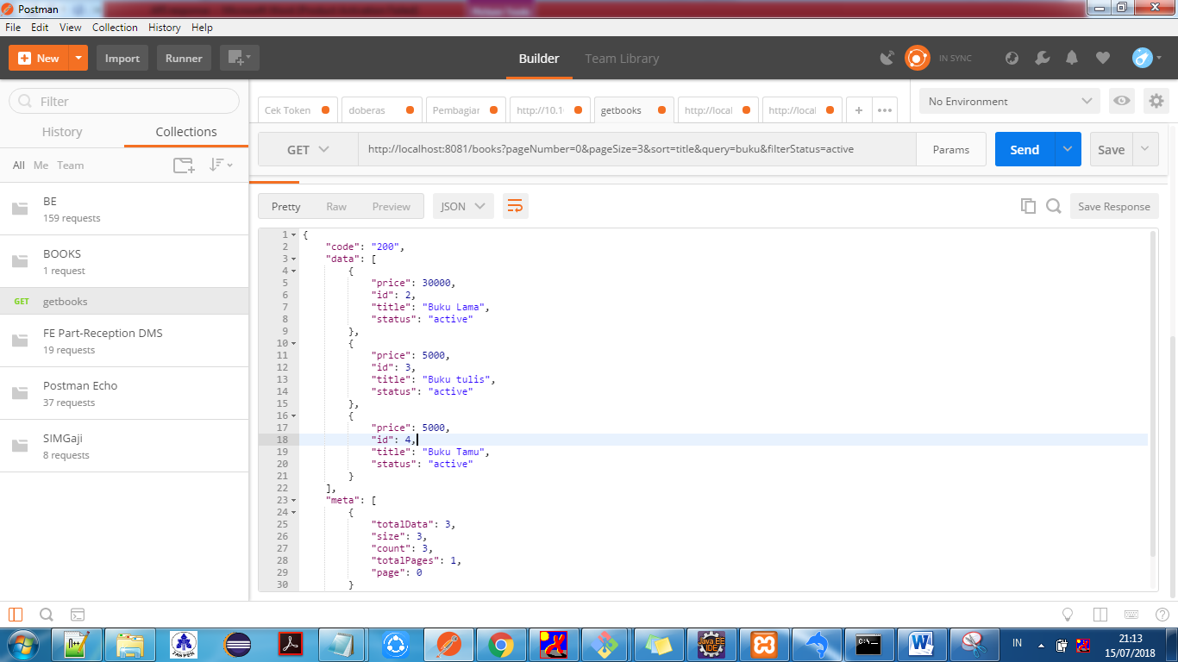

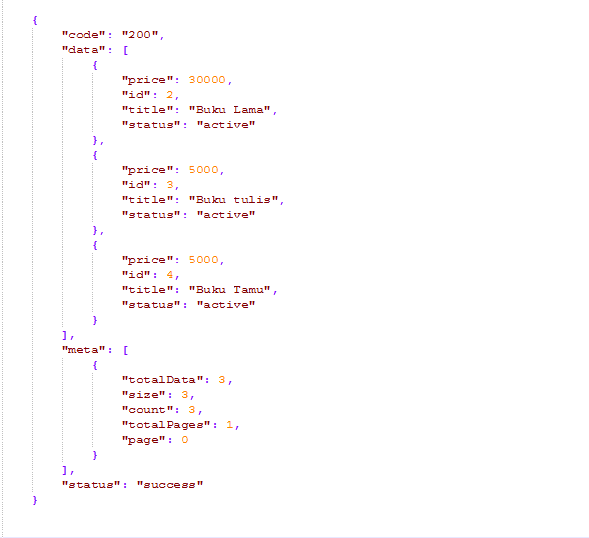

1. **API :**

<http://localhost:8081/books?pageNumber=0&pageSize=10&sort=price&query=buku&filterStatus=active>

**Respoonse :**

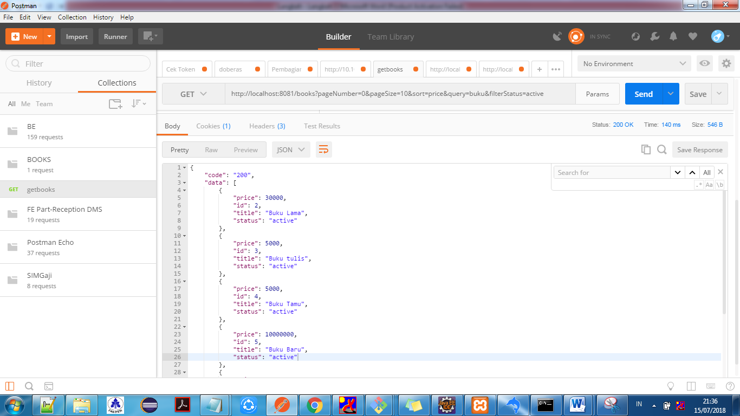

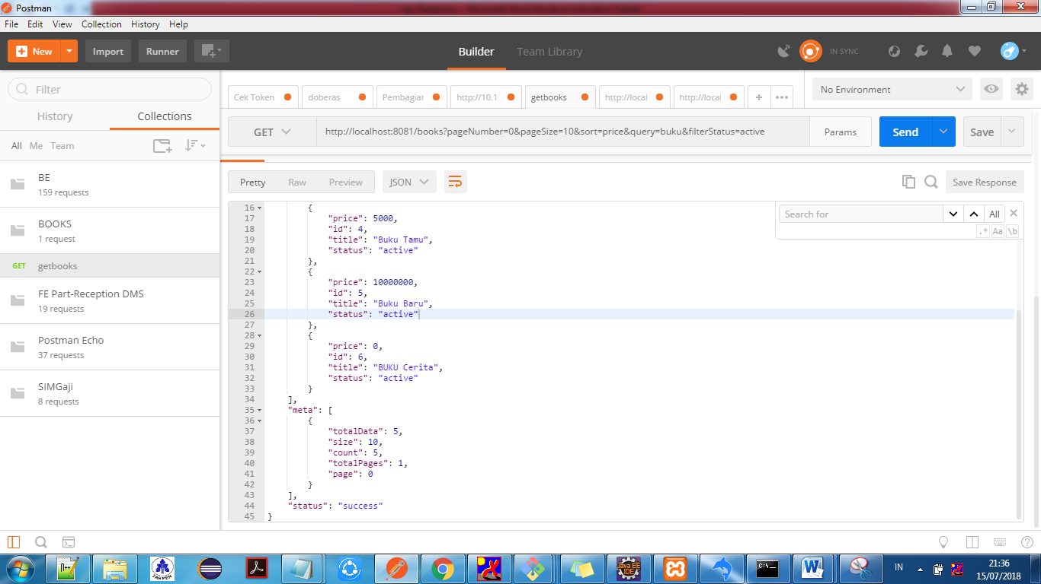

1. **API :**

<http://localhost:8081/books?pageNumber=0&pageSize=10&sort=price&query=Developer&filterStatus=active>

**Respoonse :**

